https://one.nbed.nb.ca
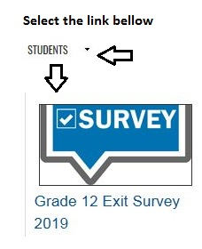

https://one.nbed.nb.ca

